**Name: Rida shafiq**

**Reg no: sp20-bse-012**

**Mad Assignment 3**

Code:

**App.js:**

import * as React from 'react';

import { Text,StyleSheet, View } from 'react-native';

import { NavigationContainer } from '@react-navigation/native';

import { createBottomTabNavigator } from '@react-navigation/bottom-tabs';

import { createNativeStackNavigator } from '@react-navigation/native-stack';

import { Ionicons } from '@expo/vector-icons';

import loginscreen from './Login';

import home from './home';

import Myprofile from './profile';

import Mysetting from './SettingsScreen';

const Tab = createBottomTabNavigator();

export default function App() {

return (

<NavigationContainer>

<Tab.Navigator

initialRouteName='loginscreen'

>

<Tab.Screen options={{

tabBarLabel: 'Home',

tabBarIcon: ({ color, size }) => (

<Ionicons name="home" color={color} size={size} />

),

}} name="Home" component={home} />

<Tab.Screen options={{

tabBarLabel: 'profile',

tabBarIcon: ({ color, size }) => (

<Ionicons name="bulb" color={color} size={size} />

),

}} name="profile" component={Myprofile} />

<Tab.Screen options={{

tabBarLabel: 'setting',

tabBarIcon: ({ color, size }) => (

<Ionicons name="settings" color={color} size={size} />

),

}} name="setting" component={Mysetting} />

</Tab.Navigator>

</NavigationContainer>

);

}

const styles = StyleSheet.create({

container: {

flex: 1,

backgroundColor: 'purple',

alignItems: 'center',

justifyContent: 'center',

},

});

**Login screen:**

import React, { Component } from 'react';

import { View, Text, StyleSheet, TextInput, TouchableOpacity } from 'react-native';

import { NavigationContainer } from '@react-navigation/native';

import { createNativeStackNavigator } from '@react-navigation/native-stack';

// create a component

const loginscreen = () => {

return (

<View style={styles.maincontainer}>

<Text style={styles.mainheader}>

Login Form

</Text>

<view style={styles.inputContainer}>

<Text style={styles.labels}>Enter your name</Text>

<TextInput style={styles.inputstyle}

autoCapitalize="none"

autoComplete={false}/>

</view>

<view style={styles.inputContainer}>

<Text style={styles.labels}>

Enter password

</Text>

<TextInput style={styles.inputstyle}

secureTextEntry={true}>

</TextInput>

</view>

<TouchableOpacity onpress={()=>{props.navigation.navigate("Home")}}

style={[

styles. loginBtn,

{backgroundColor:'pink'},

]}>

<Text>

Login

</Text>

</TouchableOpacity>

</View>

);

};

// define your styles

const styles = StyleSheet.create({

maincontainer: {

height: "100%",

paddingHorizontal: 30,

paddingTop:30,

backgroundColor: "purple",

},

mainheader : {

fontsize:50,

color:'pink',

fontWeight:"500",

paddingTop:40,

paddingBottom:15,

textTransform:"capitalize",

fontFamily:"bold"

},

labels: {

marginBottom: 5,

fontSize:18,

color:"pink",

marginTop:10,

lineHeight:25,

fontFamily:'regular',

},

inputContainer:{

marginTop:20,

},

inputView: {

backgroundColor: "#FFC0CB",

borderRadius: 30,

width: "70%",

height: 45,

marginBottom:40,

alignItems: "center",

},

inputstyle:{

borderWidth:1,

borderColor:"green",

paddingHorizontal:15,

paddingVertical:7,

borderRadius:1,

fontFamily:"regular",

fontsize:18,

},

TextInput: {

height: 50,

flex: 1,

padding: 10,

marginLeft: 20,

},

forgot_button: {

height: 30,

marginBottom: 30,

},

loginBtn: {

width: "80%",

borderRadius: 25,

height: 50,

alignItems: "center",

justifyContent: "center",

marginTop: 40,

backgroundColor: "#FF1493",

},

});

//make this component available to the app

export default loginscreen;

**Home.js:**

//import liraries

import React, { Component } from 'react';

import { View, Text, StyleSheet, Button } from 'react-native';

import { NavigationContainer } from '@react-navigation/native';

import { createNativeStackNavigator } from '@react-navigation/native-stack';

// create a component

const Home= (props) => {

return (

<View style={styles.container}>

<Text>welcome to home screen</Text>

<Button

onpress={()=>{props.navigation.navigate("Myprofile")}}

title="go to profile screen">

</Button>

<Button

onpress={()=>{props.navigation.navigate("Mysetting")}}

title="go to Mysetting">

</Button>

</View>

);

};

// define your styles

const styles = StyleSheet.create({

container: {

flex: 1,

justifyContent: 'center',

alignItems: 'center',

backgroundColor: 'grey',

},

});

//make this component available to the app

export default Home;

**Profile.js:**

//import liraries

import React, { Component } from 'react';

import { View, Text, StyleSheet ,Button} from 'react-native';

import { NavigationContainer } from '@react-navigation/native';

import { createNativeStackNavigator } from '@react-navigation/native-stack';

// create a component

const Myprofile = (props) => {

return (

<View style={styles.container}>

<Text>welcome to my profile</Text>

<Button

onpress={()=>{props.navigation.navigate("Myprofile")}}

title="go back to home">

</Button>

</View>

);

};

// define your styles

const styles = StyleSheet.create({

container: {

flex: 1,

justifyContent: 'center',

alignItems: 'center',

backgroundColor: 'grey',

},

});

//make this component available to the app

export default Myprofile;

**Setting.js:**

//import liraries

import React, { Component } from 'react';

import { View, Text, StyleSheet ,Button} from 'react-native';

import { NavigationContainer } from '@react-navigation/native';

import { createNativeStackNavigator } from '@react-navigation/native-stack';

// create a component

const Mysetting = () => {

return (

<View style={styles.container}>

<Text>welcome to setting screen</Text>

<Button

onpress={()=>{props.navigation.navigate("Myprofile")}}

title="go to home screen">

</Button>

<Button

onpress={()=>{props.navigation.navigate("Mysetting")}}

title="go to profile screen">

</Button>

</View>

);

};

// define your styles

const styles = StyleSheet.create({

container: {

flex: 1,

justifyContent: 'center',

alignItems: 'center',

backgroundColor: 'grey',

},

});

//make this component available to the app

export default Mysetting;

**Output:**

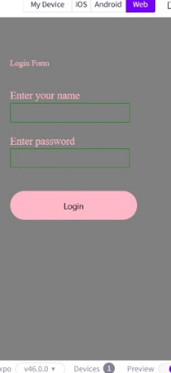

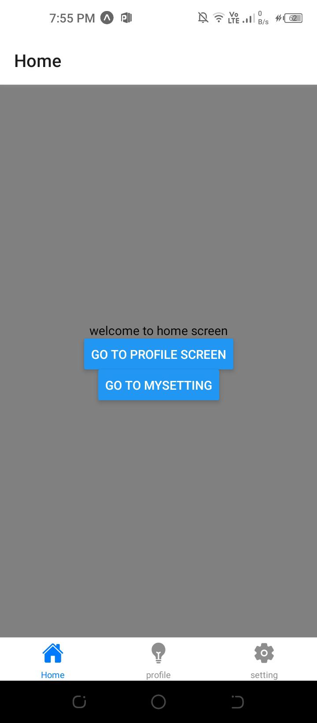

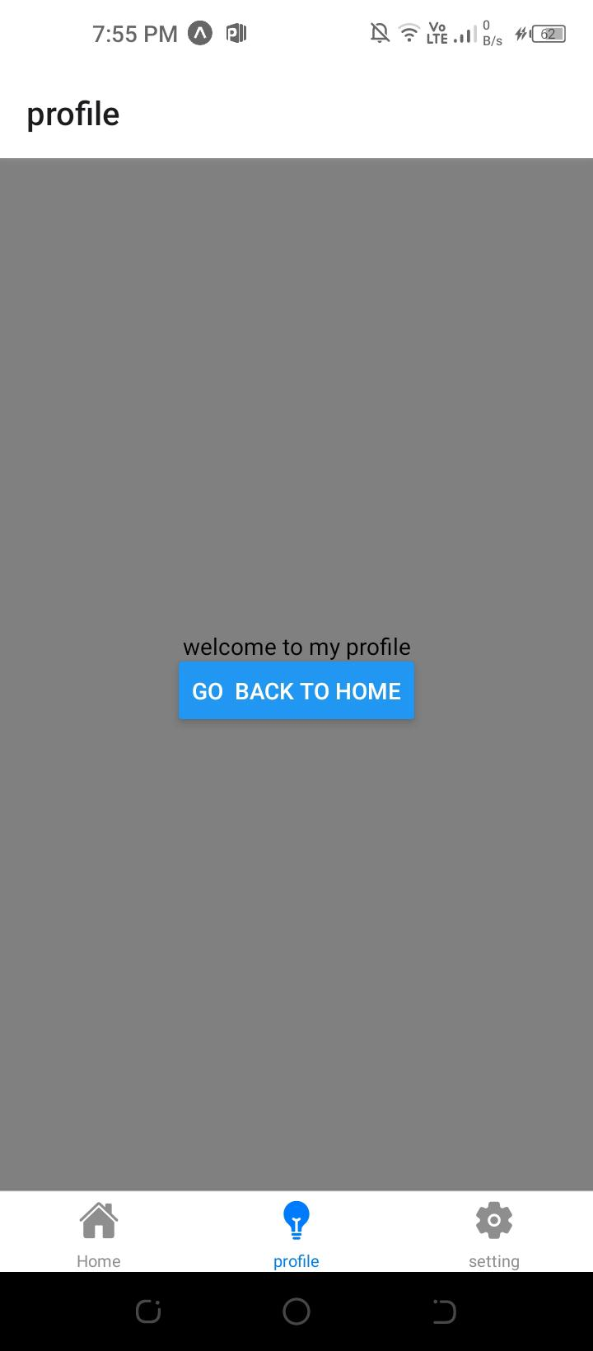

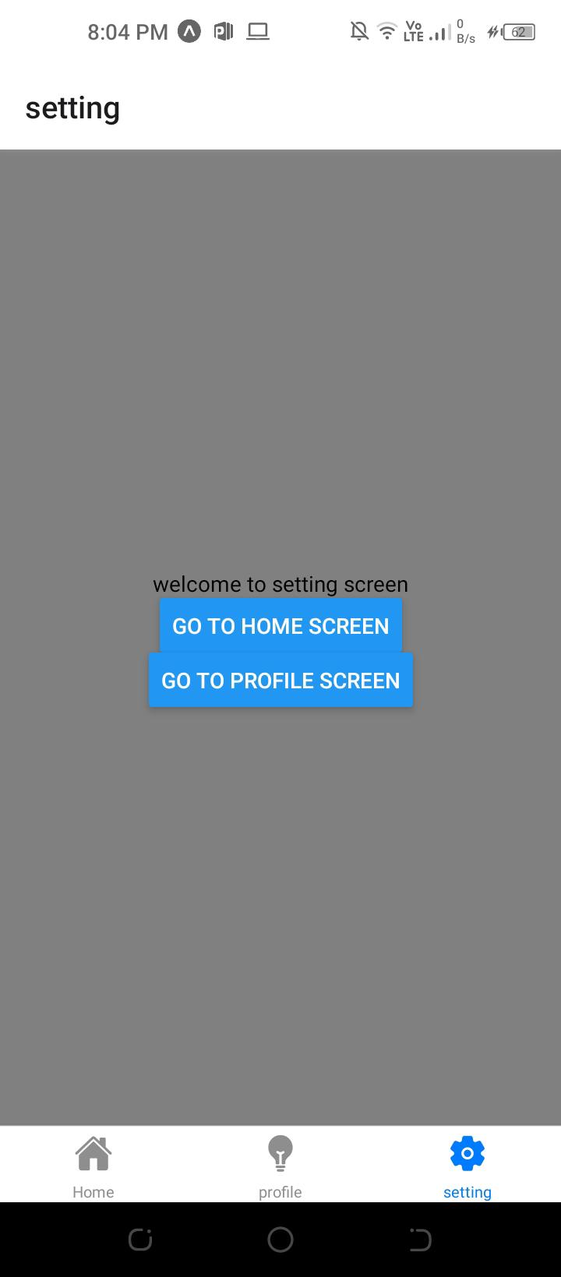

**Code:**

**App.js**

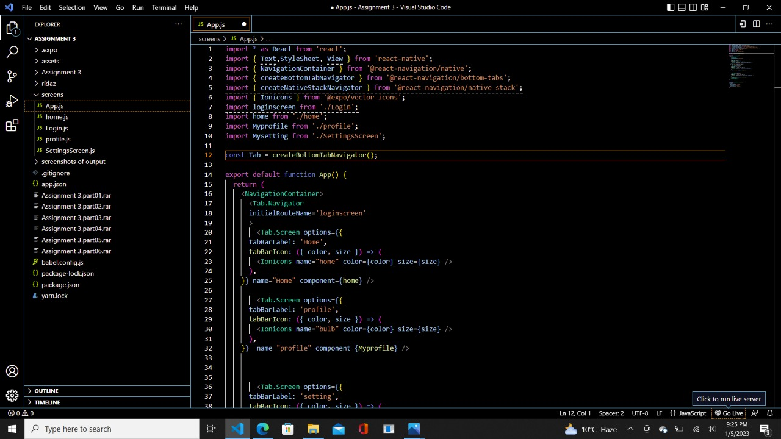

**Loginscreen:**

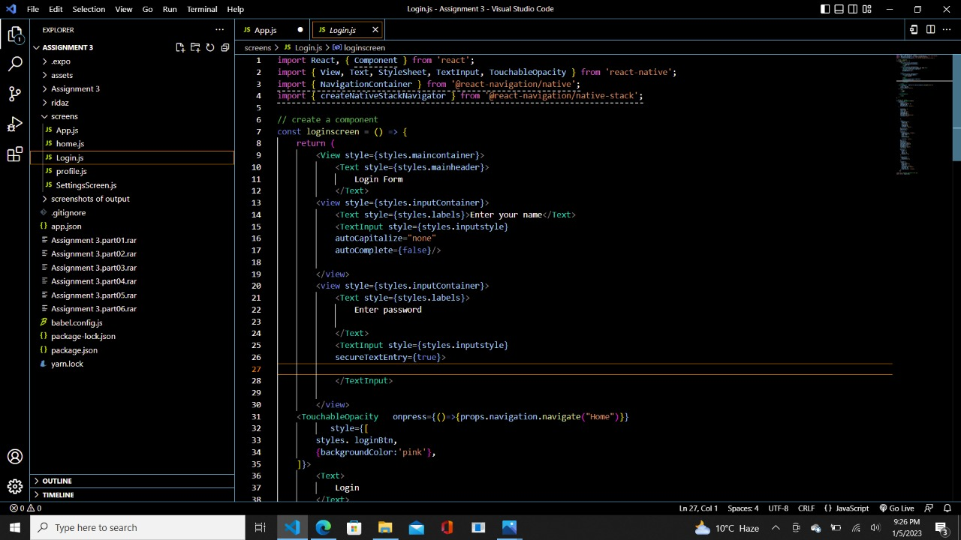

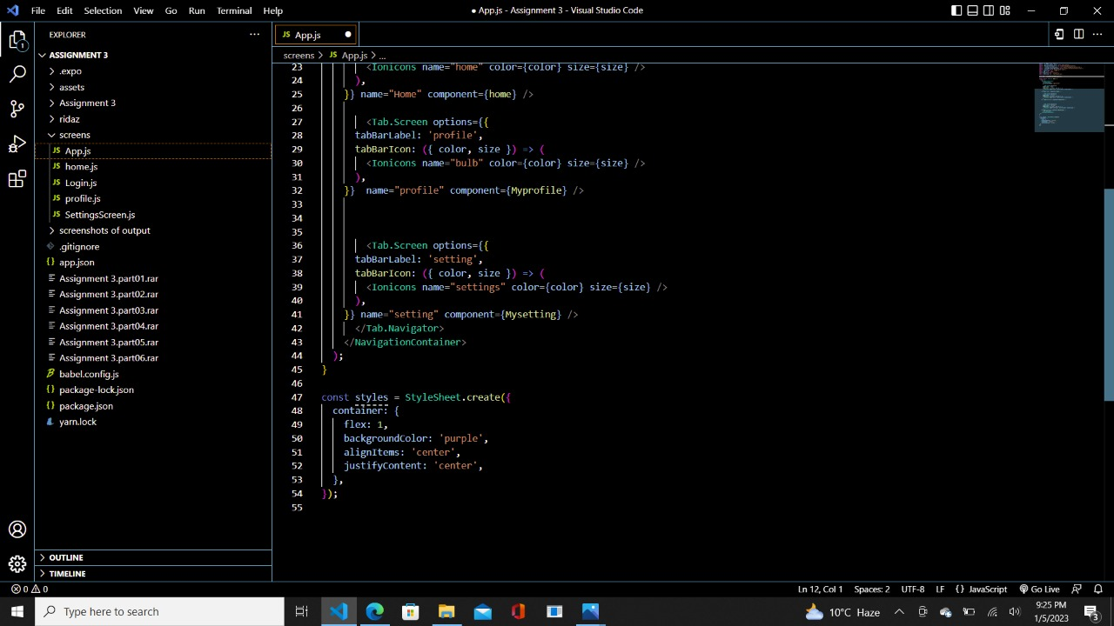

**Home.js**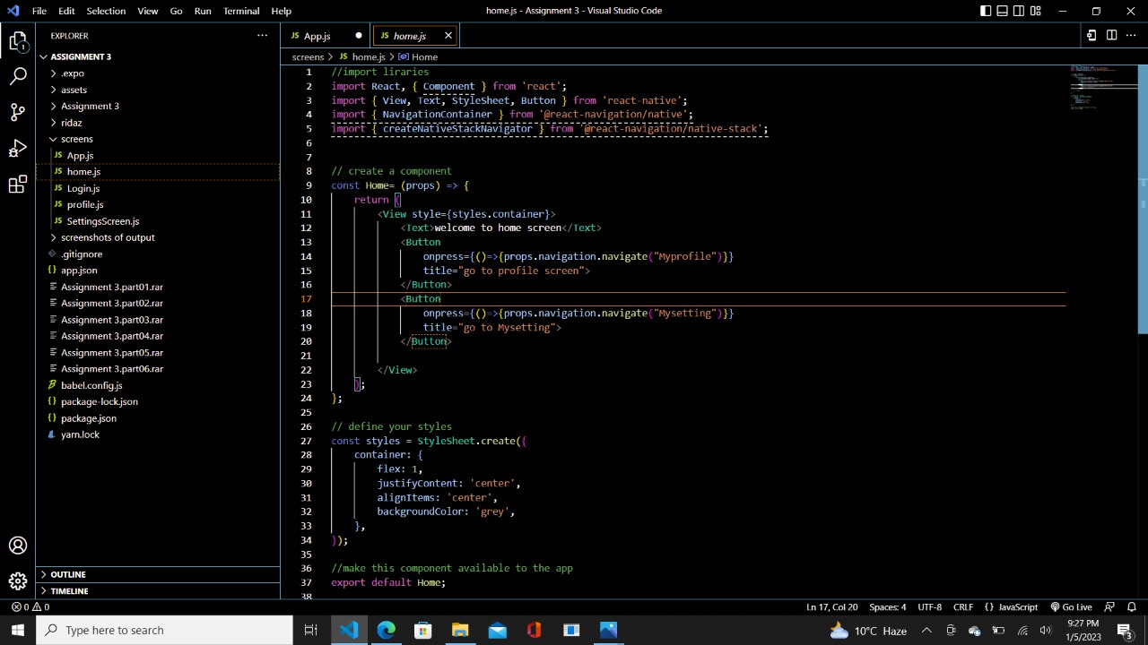

**Profile.js**

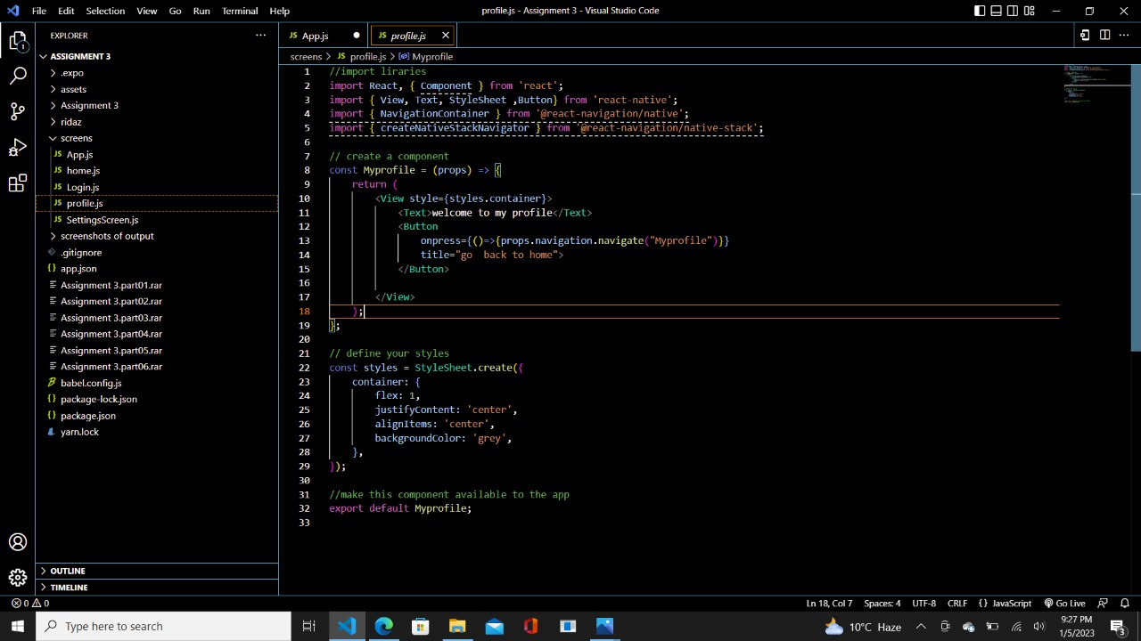

**Setting.js**

